**Question 1:**

You are given an object book with the properties title, author, and yearPublished. Perform the following operations:

1. **Access** the author property and print it.
2. **Modify** the yearPublished property to 2022.
3. **Add** a new property genre to the book object with the value “Fiction”.
4. **Delete** the title property from the book object.

var book = {

    "title" : "The Zombie Room",

    "author" : "R.D. Ronald",

    "yearPublished" : "2012",

}

console.log(book.author) //or

console.log(`author :${book.author}`) //access author property

book ['yearPublished'] = "2022"  // updated

book ['genre'] = "Fiction"  // adding new property

delete book.title

console.log(book)

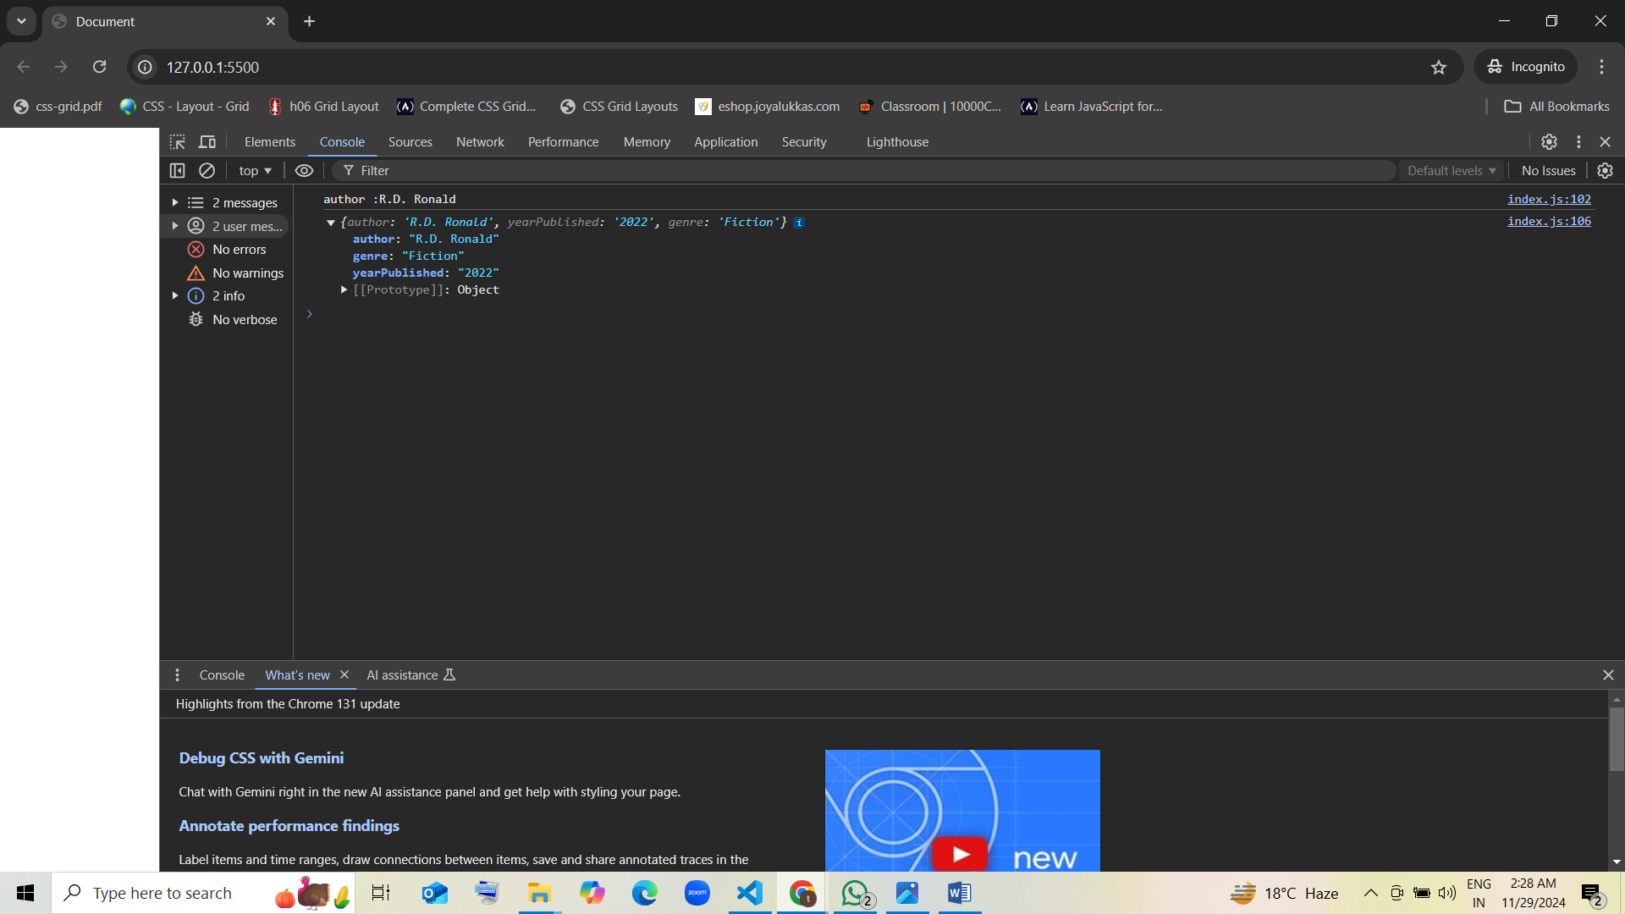

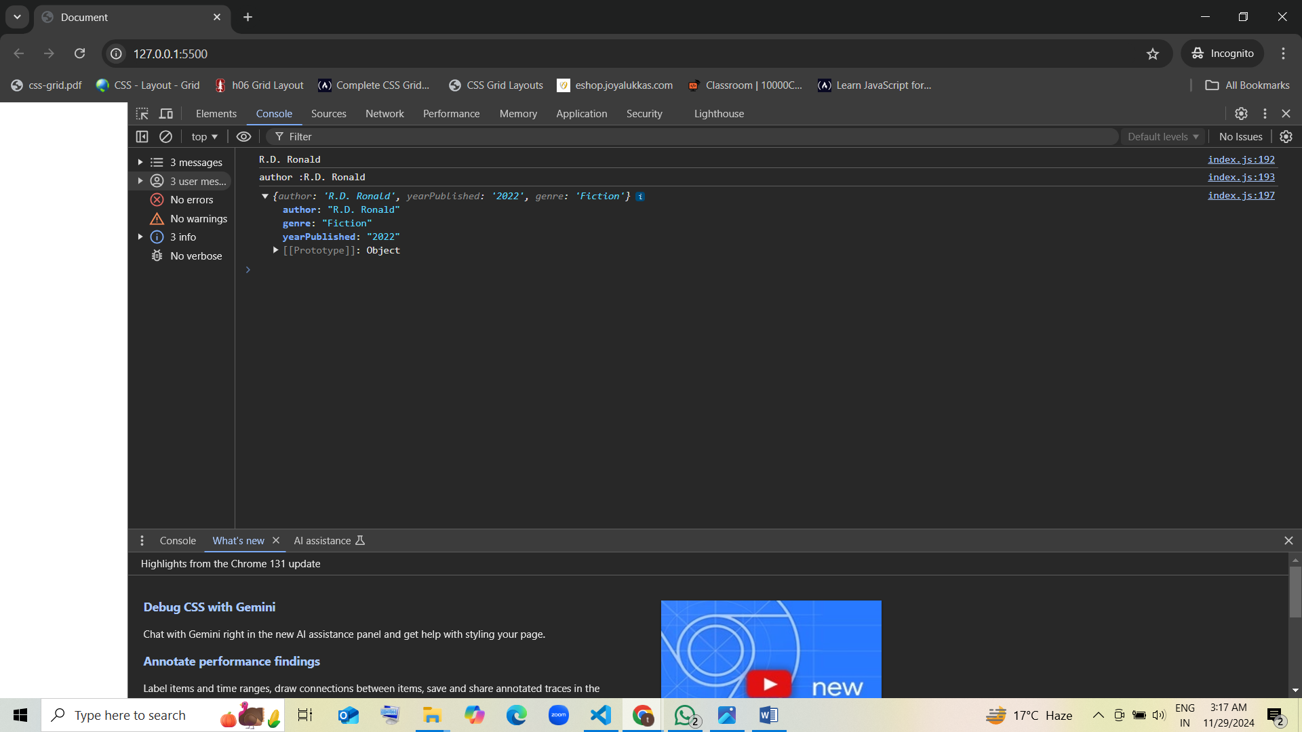

**Question 2:**

You are given an object employee with the properties name, age, position, and salary. Perform the following operations:

1. **Access** the position property and print it.
2. **Modify** the salary property to 50000.
3. **Add** a new property department to the employee object with the value “HR”.
4. **Delete** the age property from the employee object.

var employee = {

    "name" : "Akshara",

    "age" : "24",

    "position" : "Product Engineer",

    "salary" : "25000",

}

console.log(employee.position)

console.log(`position : ${employee.position}`)

employee ['salary'] = "50000"

employee ['department'] = "HR"

delete employee.age

console.log(employee)

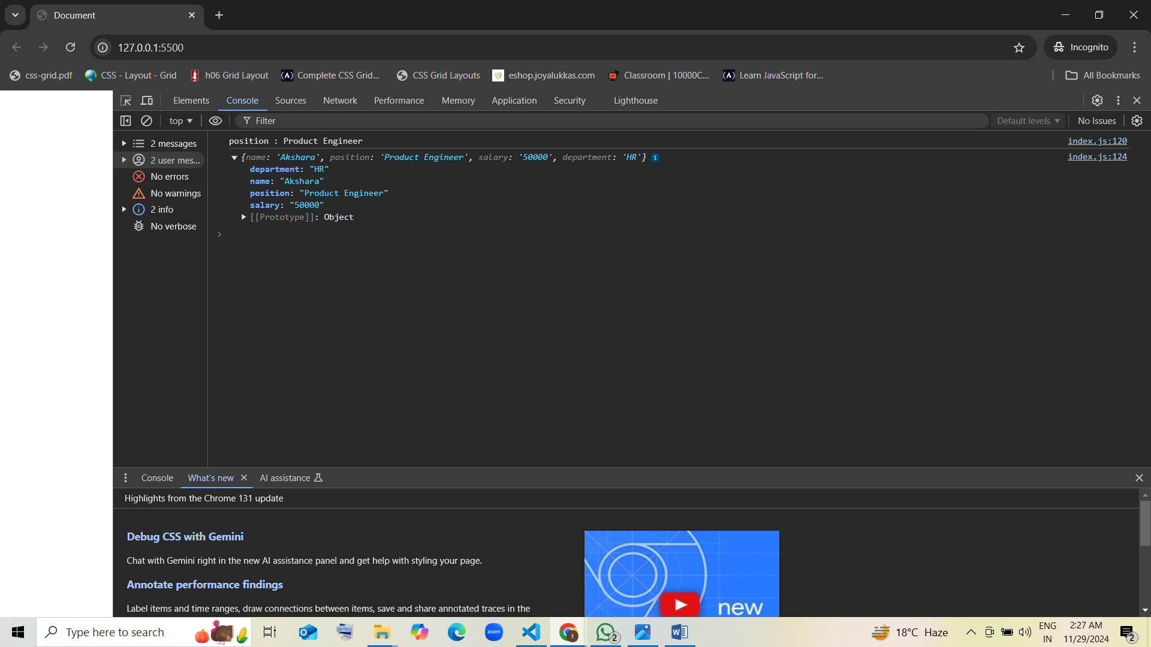

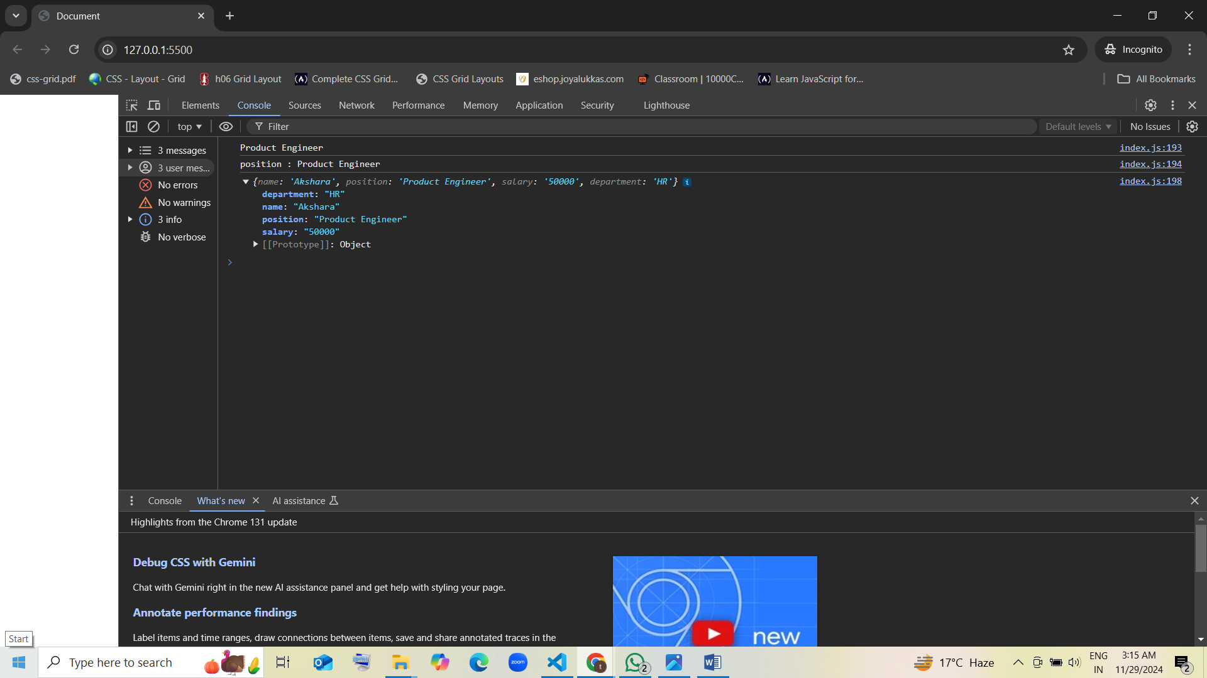

**Question 3:**

You are given an object product with the properties id, name, price, and category. Perform the following operations:

1. **Access** the price property and print it.
2. **Modify** the category property to “Electronics”.
3. **Add** a new property inStock to the product object with the value true.
4. **Delete** the id property from the product object.

var product = {

    "id" : "TME1D2",

    "name" : "Zedteck Deck Oven",

    "price" : "32000",

    "category" : "Single deck oven",

}

console.log(product.price)

console.log(`price : ${product.price}`)

product ['category'] = "Electronics"

product ['inStock'] = "true"

delete product.id

console.log(product)

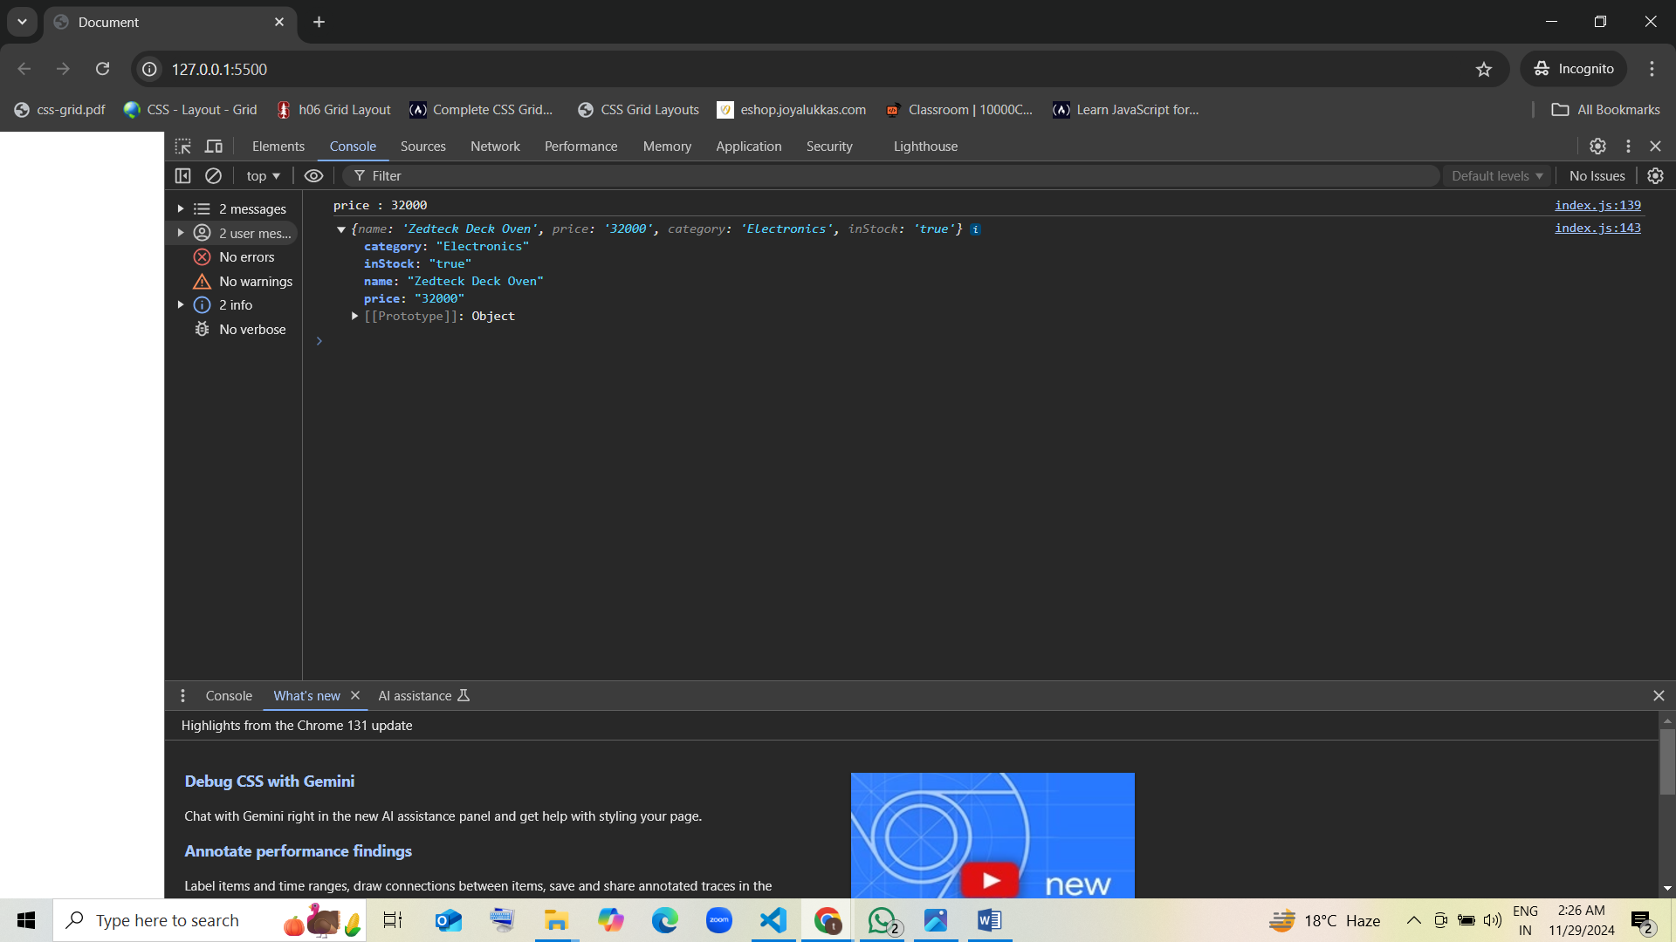

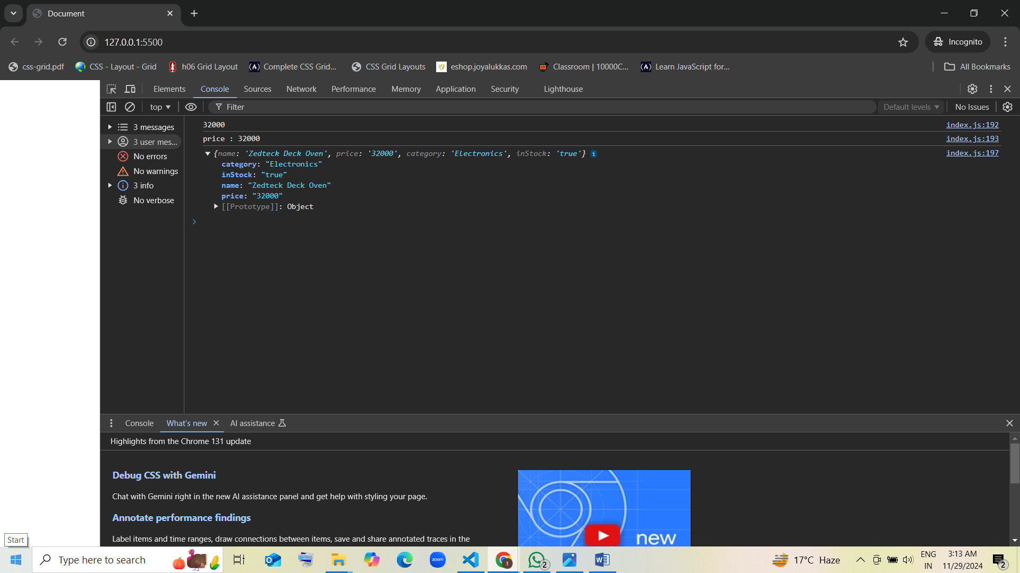

**Question 4:**

You are given an object car with the properties make, model, year, and color. Perform the following operations:

1. **Access** the make property and print it.
2. **Modify** the color property to “Black”.
3. **Add** a new property engineType to the car object with the value “V6”.
4. **Delete** the year property from the car object.

var car = {

    "make" : "South Korea",

    "model" : "SX Opt Turbo DCT DT",

    "year" : "2006",

    "color" : "Fiery Red",

}

console.log(car.make)

console.log(`property : ${car.make}`)

car ['color'] = "Black"

car ['engineType'] = "V6"

delete car.year

console.log(car)

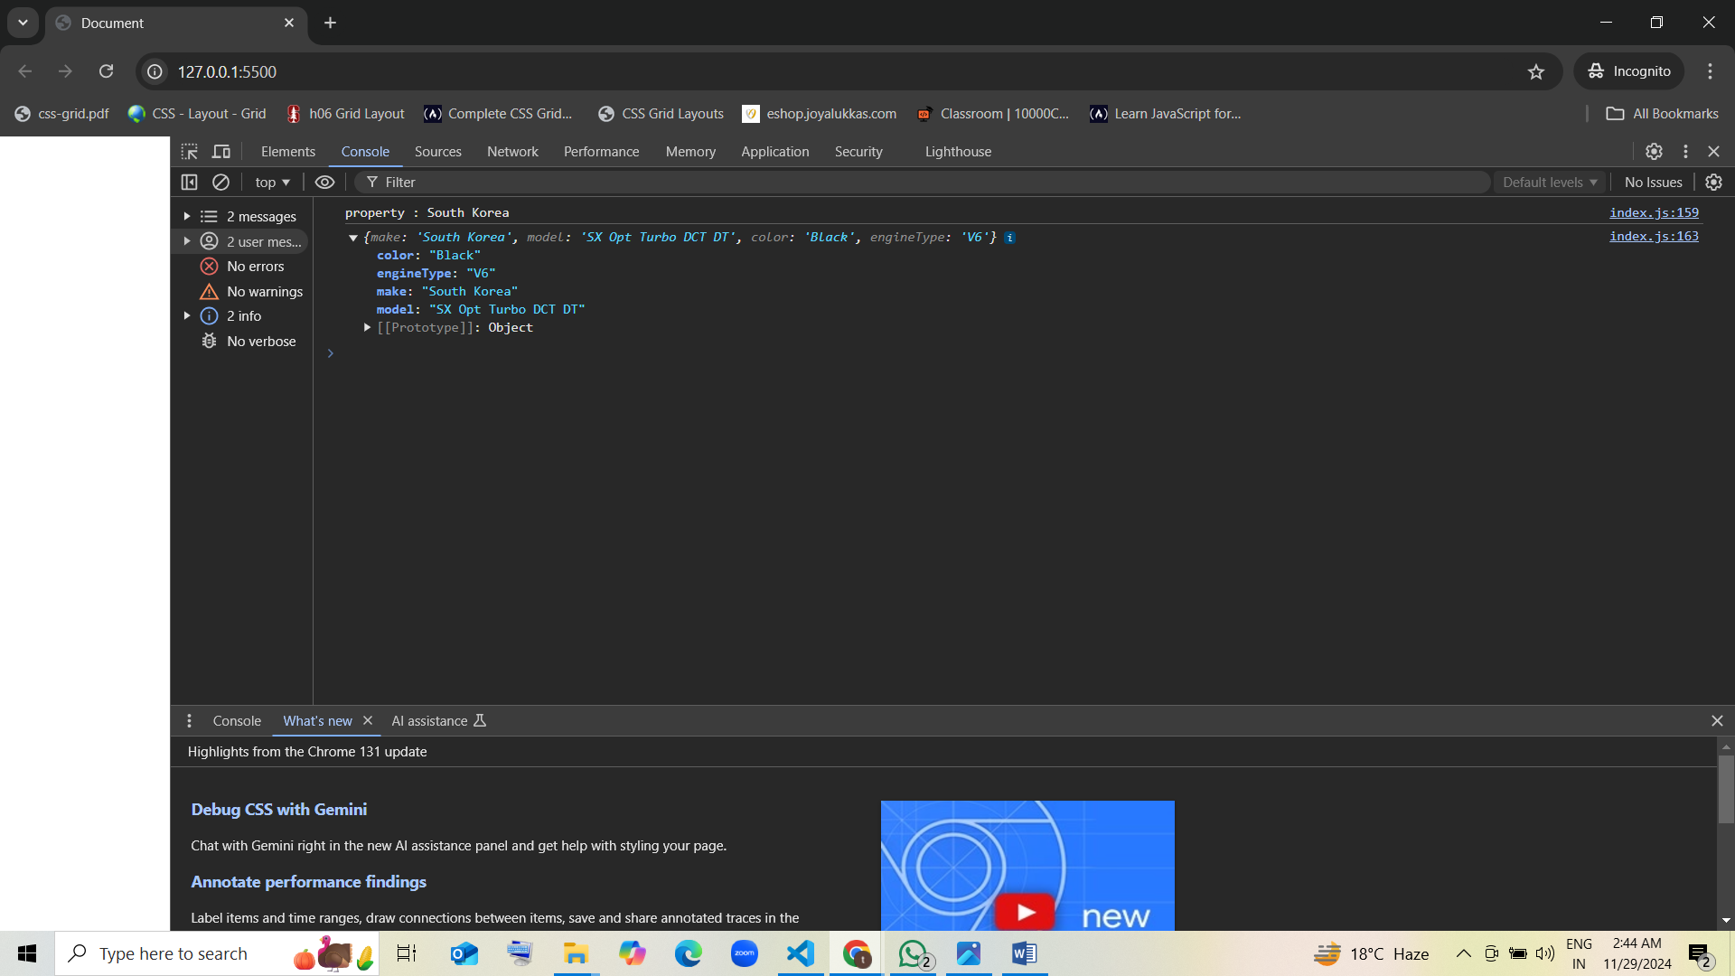

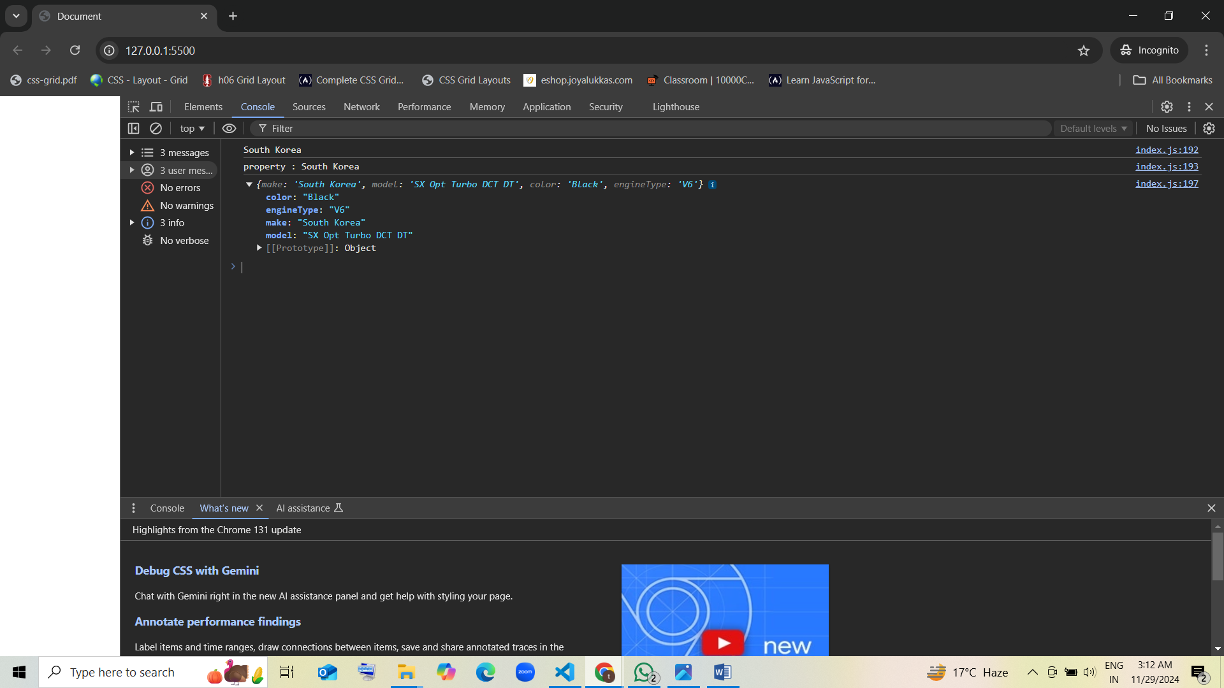

**Question 5:**

You are given an object student with the properties name, age, grade, and school. Perform the following operations:

1. **Access** the school property and print it.
2. **Modify** the grade property to 95.
3. **Add** a new property hobbies to the student object with the value ["reading", "sports"].
4. **Delete** the age property from the student object.

var student = {

    "name" : "Shruthi",

    "age" : "14",

    "grade" : "A",

    "school" : "ST. Mary's School",

}

console.log(student.school)

console.log(`school : ${student.school}`)

student ['grade'] = "95"

student ['hobbies'] = "reading  sports" ,

delete student.age

console.log(student)

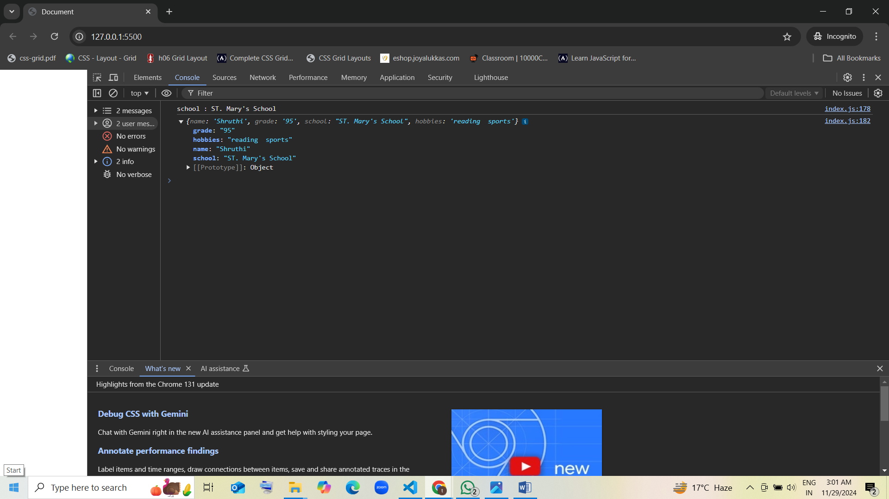

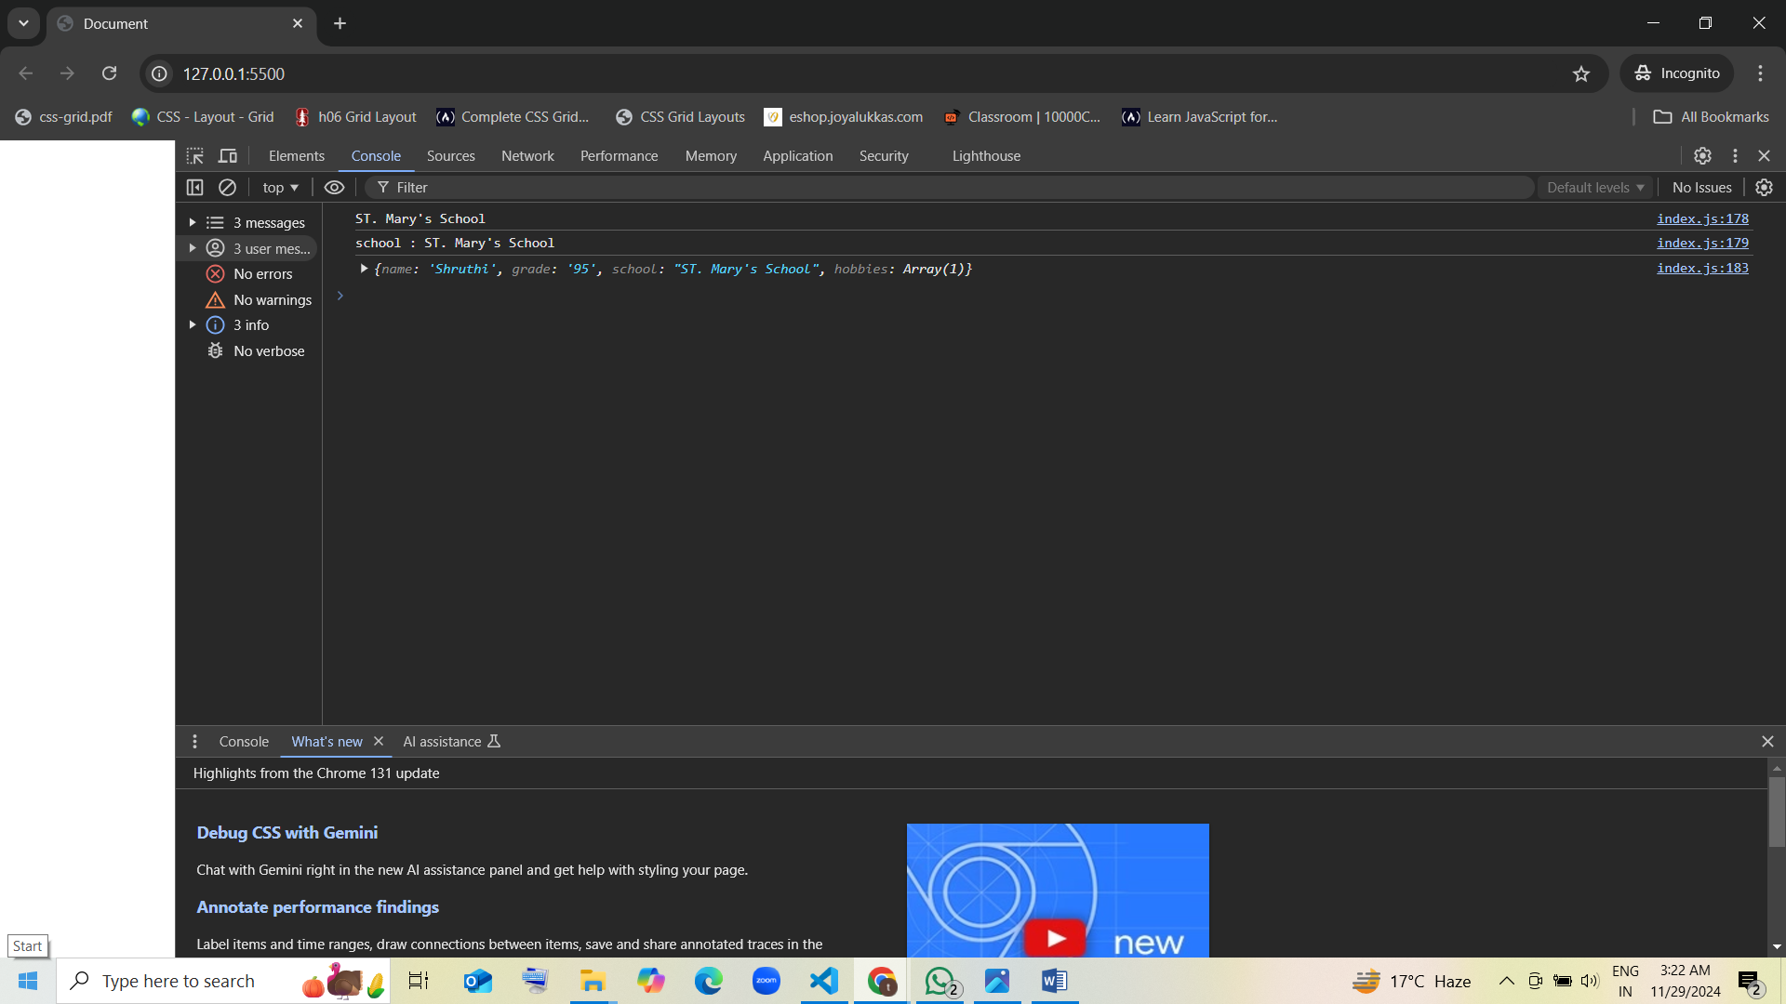

**Question 6:**

You are given an object user with the following structure:

const user = {  
 username: "john_doe",  
 profile: {  
 firstName: "John",  
 lastName: "Doe",  
 age: 28,  
 address: {  
 street: "456 Elm St",  
 city: "Gotham",  
 zip: "54321"  
 }  
 },  
 preferences: {  
 theme: "dark",  
 notifications: true  
 }  
};

const user = {

    username: "john_doe",

    profile: {

      firstName: "John",

      lastName: "Doe",

      age: 28,

      address: {

        street: "456 Elm St",

        city: "Gotham",

        zip: "54321"

      }

    },

    preferences: {

      theme: "dark",

      notifications: true

    }

  };

console.log(user.profile.address.city)

user.preferences ['theme'] = "light"

user.profile ['phone'] = "555-9876"

delete user.profile.address.zip

console.log(user)

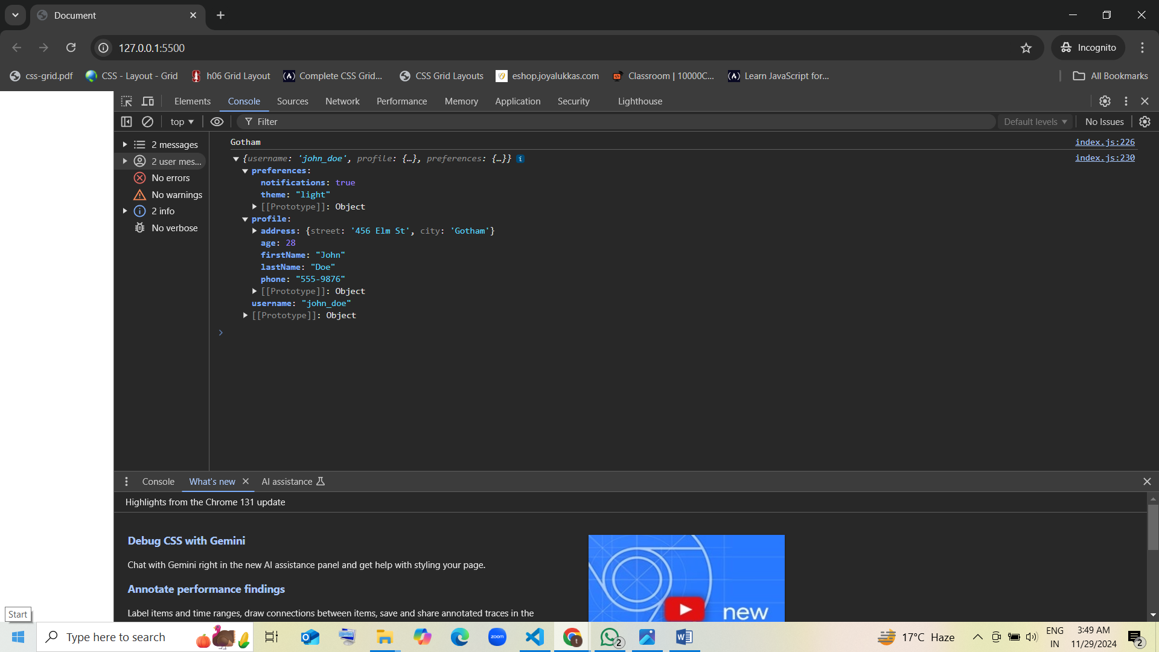

Perform the following operations:

1. **Access** the city property from the address object and print it.
2. **Modify** the theme property in the preferences object to “light”.
3. **Add** a new property phone to the profile object with the value “555-9876”.
4. **Delete** the zip property from the address object.

**Question 7:**

You are given an object company with the following structure:

const company = {  
 name: "Tech Solutions",  
 employees: [  
 {  
 name: "Alice",  
 position: "Developer",  
 contact: {  
 email: "alice@tech.com",  
 phone: "555-2345"  
 }  
 },  
 {  
 name: "Bob",  
 position: "Manager",  
 contact: {  
 email: "bob@tech.com",  
 phone: "555-6789"  
 }  
 }  
 ],  
 location: "New York"  
};

Perform the following operations:

1. **Access** the email of the second employee (Bob) and print it.
2. **Modify** the phone number of Alice to “555-1111”.
3. **Add** a new property department with the value “Engineering” to the first employee (Alice).
4. **Delete** the location property from the company object.

const company = {

    name: "Tech Solutions",

    employees: [

      {

        name: "Alice",

        position: "Developer",

        contact: {

          email: "alice@tech.com",

          phone: "555-2345"

        }

      },

      {

        name: "Bob",

        position: "Manager",

        contact: {

          email: "bob@tech.com",

          phone: "555-6789"

        }

      }

    ],

    location: "New York"

};

console.log(company.employees[1].contact.email)   // 2nd element

company.employees[0].contact['phone'] = "555-1111"

company.employees[0]['department'] = "Engineering"

delete company.location

console.log(company)

